**PIZZA SALES SQL QUERIES**

**A. KPI’s**

**1. Total Revenue:**

Ans. select ROUND(SUM(total_price),2) from pizza_sales

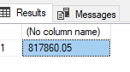

**2. Average Order Value**

Ans select ROUND(sum(total_price)/(COUNT(distinct(order_id))),2) as Average_order_value from pizza_sales

Average_order_value

38.31

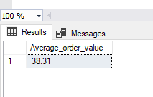

**3. Total Pizzas Sold**

**Ans** select sum(quantity) as Total_pizza_sold from pizza_sales  
  
Total_pizza_sold

49574

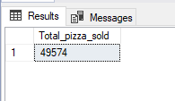

**4. Total Orders**

Ans select COUNT(distinct(order_id)) as Total_Order from pizza_sales  
  
Total_Order

21350

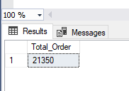

**5. Average Pizzas Per Order  
Ans.**

select CAST(CAST(SUM(quantity) as decimal(10,2))/CAST(COUNT(distinct(order_id)) as decimal(10,2)) as decimal(10,2))

as Average_pizza_per_order from pizza_sales  
  
Average_pizza_per_order

2.32

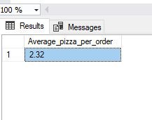

**Problem Statement   
Chart Requirement :**

1. **Daily Trend for Total Orders**

**Ans**select DATENAME(WEEKDAY,order_date) as order_day,count(distinct(order_id)) as total_orders from pizza_sales

group by DATENAME(WEEKDAY,order_date)

order by total_orders desc

**order_day total_orders**

**Friday 3538**

**Thursday 3239**

**Saturday 3158**

**Wednesday 3024**

**Tuesday 2973**

**Monday 2794**

**Sunday 2624**

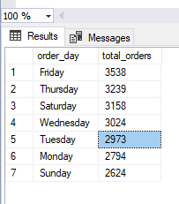

1. **Monthly Trend for Orders**

Ans  
select DATENAME(MONTH,order_date) as month_name,COUNT(distinct(order_id)) as total_order from pizza_sales

group by DATENAME(MONTH,order_date)

order by total_order desc

month_name total_order

July 1935

May 1853

January 1845

August 1841

March 1840

April 1799

November 1792

June 1773

February 1685

December 1680

September 1661

October 1646

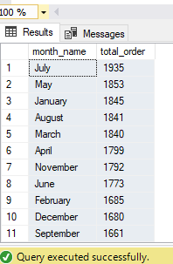

**3**

**% of Sales by Pizza Category**

**Ans..**

select pizza_category,round(sum(total_price)*100/(select sum(total_price) from pizza_sales),2) as saless_per from pizza_sales

group by pizza_category

order by saless_per desc

**pizza_category saless_per**

**Classic 26.91**

**Supreme 25.46**

**Chicken 23.96**

**Veggie 23.68**

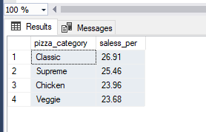

1. **% of Sales by Pizza Size**

Ans

pizza_size sales_per

L 45.89

M 30.49

S 21.77

XL 1.72

XXL 0.12

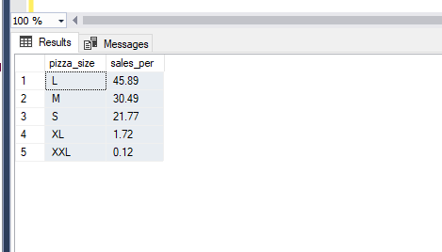

1. **Total Pizzas Sold by Pizza Category**

**Ans**

select pizza_category,sum(quantity) as Total_Pizza from pizza_sales

group by pizza_category

order by Total_Pizza desc

pizza_category Total_Pizza

Classic 14888

Supreme 11987

Veggie 11649

Chicken 11050

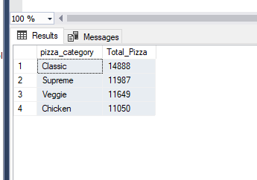

**G. Top 5 Pizzas by Revenue**

select top 5 pizza_name,ROUND(SUM(total_price),2) as total_revenue from pizza_sales

group by pizza_name

order by total_revenue desc

**pizza_name total_revenue**

**The Thai Chicken Pizza 43434.25**

**The Barbecue Chicken Pizza 42768**

**The California Chicken Pizza 41409.5**

**The Classic Deluxe Pizza 38180.5**

**The Spicy Italian Pizza 34831.25**

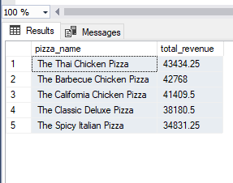

**H. Bottom 5 Pizzas by Revenue**

**Ans**

select top 5 pizza_name,ROUND(SUM(total_price),2) as total_revenue from pizza_sales

group by pizza_name

order by total_revenue

**pizza_name total_revenue**

**The Brie Carre Pizza 11588.5**

**The Green Garden Pizza 13955.75**

**The Spinach Supreme Pizza 15277.75**

**The Mediterranean Pizza 15360.5**

**The Spinach Pesto Pizza 15596**

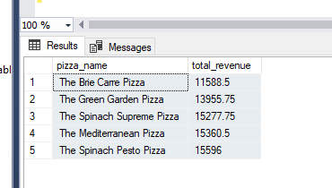

**I. Top 5 Pizzas by Quantity**

**Ans** select top 5 pizza_name,sum(quantity) as Total_qyantity from pizza_sales

group by pizza_name

order by Total_qyantity desc

**pizza_name Total_qyantity**

**The Classic Deluxe Pizza 2453**

**The Barbecue Chicken Pizza 2432**

**The Hawaiian Pizza 2422**

**The Pepperoni Pizza 2418**

**The Thai Chicken Pizza 2371**

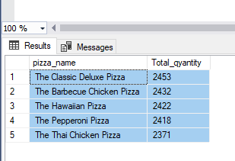

**J. Bottom 5 Pizzas by Quantity**

**Ans** select top 5 pizza_name,sum(quantity) as Total_qyantity from pizza_sales

group by pizza_name

order by Total_qyantity desc

**pizza_name Total_qyantity**

**The Brie Carre Pizza 490**

**The Mediterranean Pizza 934**

**The Calabrese Pizza 937**

**The Spinach Supreme Pizza 950**

**The Soppressata Pizza 961**

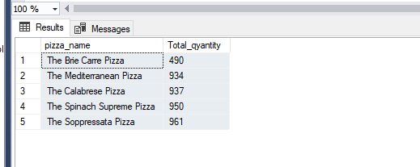

**K. Top 5 Pizzas by Total Orders**

**Ans .**

select top 5 pizza_name,count(distinct(order_id)) as total_order from pizza_sales

group by pizza_name

order by total_order desc

**pizza_name total_order**

**The Classic Deluxe Pizza 2329**

**The Hawaiian Pizza 2280**

**The Pepperoni Pizza 2278**

**The Barbecue Chicken Pizza 2273**

**The Thai Chicken Pizza 2225**

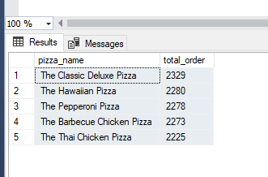

**L. Borrom 5 Pizzas by Total Orders**

**Ans**

select top 5 pizza_name,count(distinct(order_id)) as total_order from pizza_sales

group by pizza_name

order by total_order

pizza_name total_order

The Brie Carre Pizza 480

The Mediterranean Pizza 912

The Spinach Supreme Pizza 918

The Calabrese Pizza 918

The Chicken Pesto Pizza 938

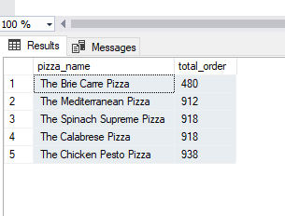

***NOTE***

If you want to apply the pizza_category or pizza_size filters to the above queries you can use WHERE clause. Follow some of below examples

SELECT Top 5 pizza_name, COUNT(DISTINCT order_id) AS Total_Orders

FROM pizza_sales

WHERE pizza_category = 'Classic'

GROUP BY pizza_name

ORDER BY Total_Orders ASC